Mini Project 2
INFO 4340

for
Dr. Christopher Nelson

Prepared by:

Bernie Dulatre, Liang Lu, Alejandro Arboleda

Table of Contents

Table of Figures iii
List of Tables iv
Introduction 5
Method 5
Result 12
Discussion 13
Appendix A- Parallel Analysis in SPSS 14
Appendix B- Factor Analysis in Python 21

Table of Figures

Figure 1 – Scree plot of all items 5

Figure 2 – cronbach’s entire set alpha of all 5 factors 12

Figure 3 - Factor 1 -Cronbach’s Alpha using SPSS 18

Figure 4 -Factor 2 -Cronbach’s Alpha using SPSS 18

Figure 5 -Factor 3 -Cronbach’s Alpha using SPSS 19

Figure 6 -Factor 4 -Cronbach’s Alpha using SPSS 19

Figure 7 -Factor 5 -Cronbach’s Alpha using SPSS 20

List of Tables

Table 1 – PCA corrolation with Factor numbers, Eigenvalues and Cum Percentages of total variance 6

Table 2 – value interpretation of items of 8 Factors using Varimax rotation 7

Table 3 - Identifying cross-loading in the factors using Varimax rotation 8

Table 4 – value interpretation of items of 8 Factors using Oblimin rotation 9

Table 5 – value interpretation of items of 5 Factors using Oblimin rotation 11

Table 6 – showing the results of the Spearman Brown Formula for factor 4 analysis 12

Table 7 - Eigenvalues with raw data 14

Table 8 - Eigenvalues with Parallel Analysis 16

Introduction

We were asked to analyze the survey results from the team Excellence Data to understand effectiveness of the questions asked within the survey. In the original survey 8 Sections were present. These are; Clear, Elevating Goals, Results-Driven Structure, Competent Team members, Unified Commitment, Collaborative Climate, Standards of Excellence, External Support and Recognition, and Principled Leadership.
Our analysis was focused on determining the optimum Factor amount for the items in the survey.

Method

- How many factors does the scree plot suggest underlie the items?

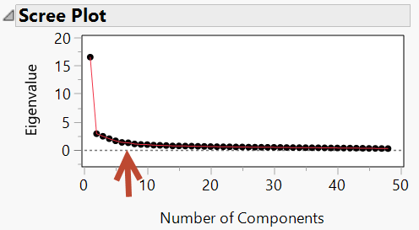
Figure 1 – Scree plot of all items

There are 8 factors that the scree plot suggests.

- What are the values of the eigenvalues and percentage of variance accounted for by the latent constructs. Provide an interpretation of these numbers.
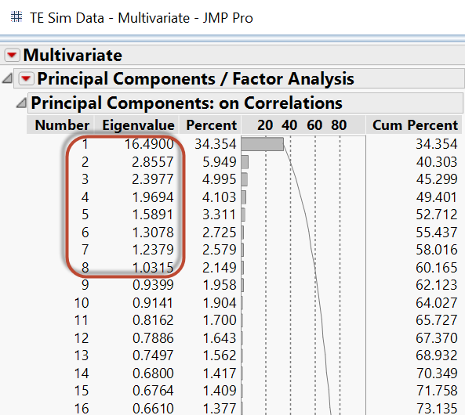
Table 1 – PCA corrolation with Factor numbers, Eigenvalues and Cum Percentages of total variance

The Eigenvalue of the first Factor is 16.49 and represents 34.354 percent of the variance in the data. This is the largest value. Factors 2-8 have decreesing values of 2.8557 down to 1.0315. All first 8 factors have Eigenvalues larger than 1.00 per the Kaiser criteria. All toghether these 8 Factors represent 60.165 % of variance in the data.

c. What are the values for the factor loadings?
- Interpret these numbers.
Using PCA we used varimax with 8 factors to derive the below results. There was cross-loading in some of the factors (see table x). We then ran PCA using Oblimin and 8 factors.
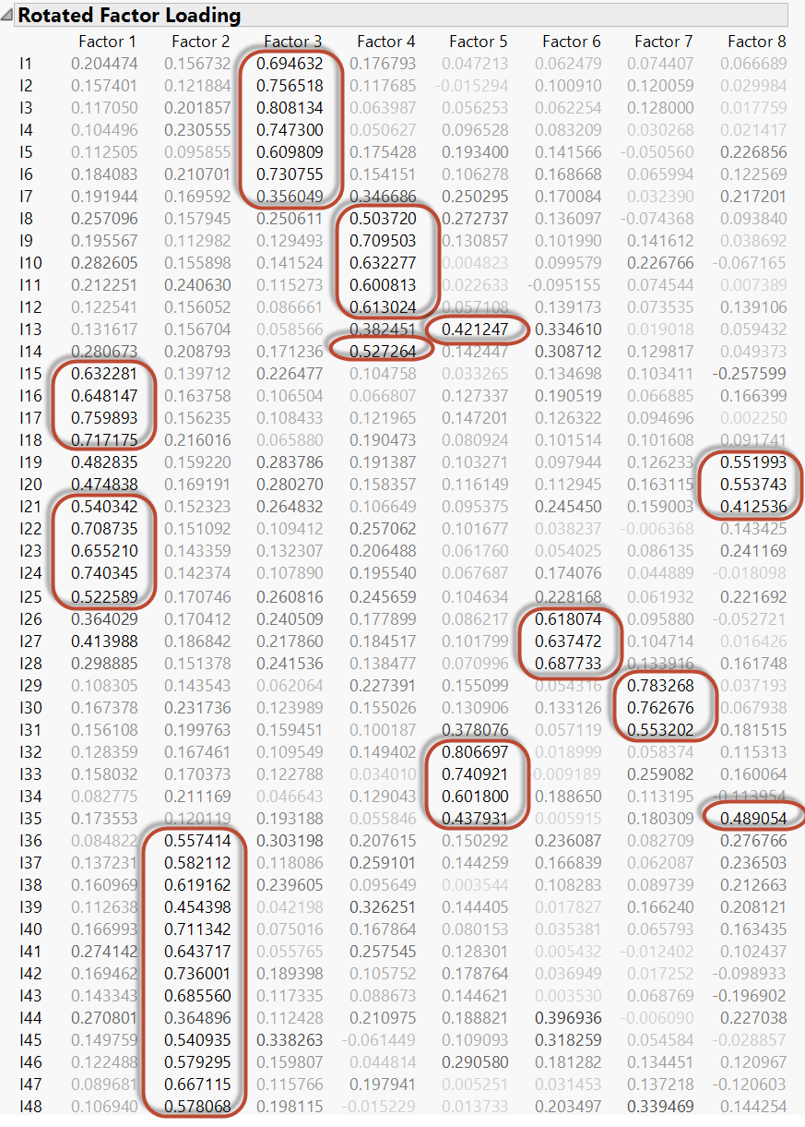
Table 2 – value interpretation of items of 8 Factors using Varimax rotation

The item numbers where split up into bundles like shown in table x for each factor.

- Identify any problematic loadings and any cross-loadings.
Item | Factor 1 | Factor 2 | Factor 3 | Factor 4 | Factor 5 | Factor 6 | Factor 7 | Factor 8
7 |  |  | 0.356 | 0.347
13 |  |  |  | 0.382 | 0.421 | 0.335
19 | 0.483 |  |  |  |  |  |  | 0.552
20 | 0.475 |  |  |  |  |  |  | 0.554
21 | 0.54 |  |  |  |  |  |  | 0.413
26 | 0.364 |  |  |  |  | 0.618
27 | 0.414 |  |  |  |  | 0.627
31 |  |  |  |  | 0.378 | 0.553
35 |  |  |  |  | 0.438 |  |  | 0.489
39 |  | 0.454 |  | 0.326
44 |  | 0.365 |  |  |  | 0.397
45 |  | 0.541 | 0.338 |  |  | 0.318
48 |  | 0.578 |  |  |  |  | 0.339
Table 3 - Identifying cross-loading in the factors using Varimax rotation

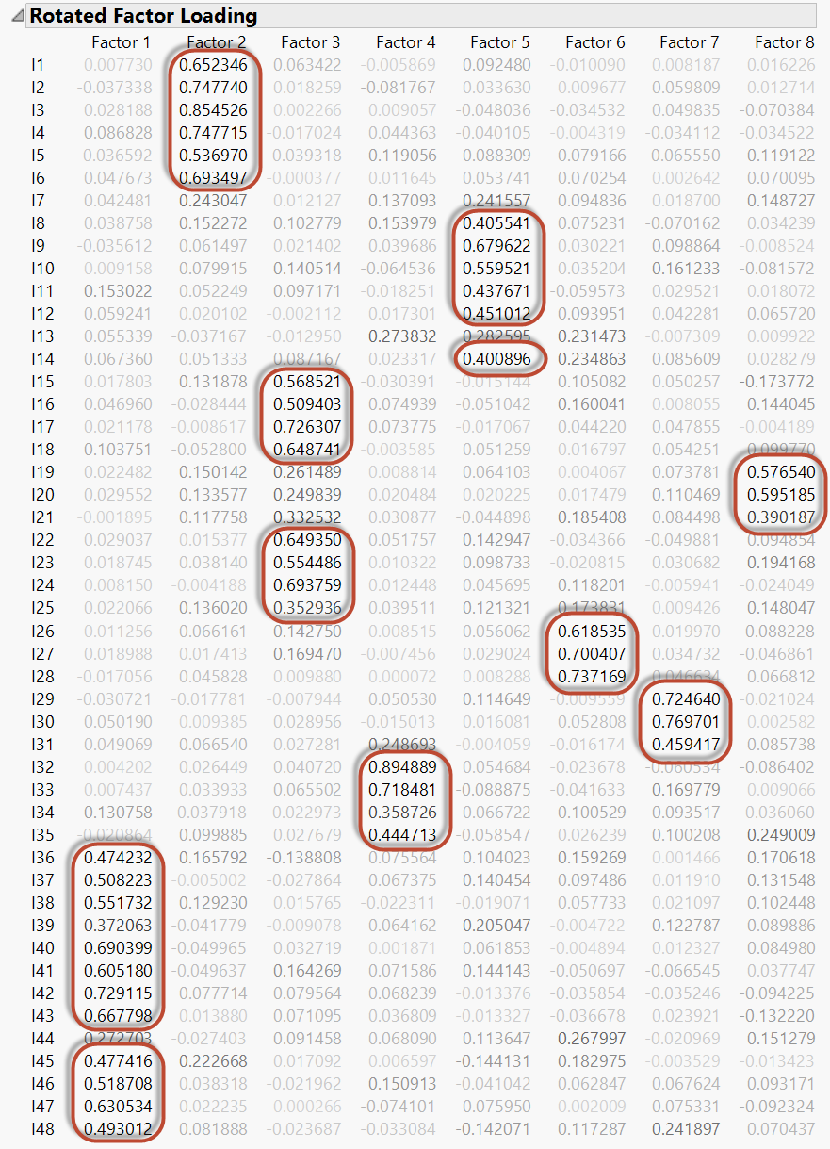
Table 4 – value interpretation of items of 8 Factors using Oblimin rotation

The item numbers where split up into bundles like shown in table x for each factor. Using Oblimin Rotation we identified 3 items to be removed. These items are: I7, I13, and I44

- How many factors should we retain?
We will retain 5 out of the 8 factors.

- What is your substantive interpretation of the factor(s)?

We decided to minimize the factors from 8 to five to have a better item conglomerate. For example. The questions that were populated in factors, 6,7 &8 are now in factor 1 (out of five). We believe this Factor reduction will aid us in better interpreting item effectiveness.

- Conduct an item analysis for each factor that you retained. Are all items functioning appropriately? If not, describe your decisions to refine the instrument.

Item I7 was not included in any factor so we removed it.

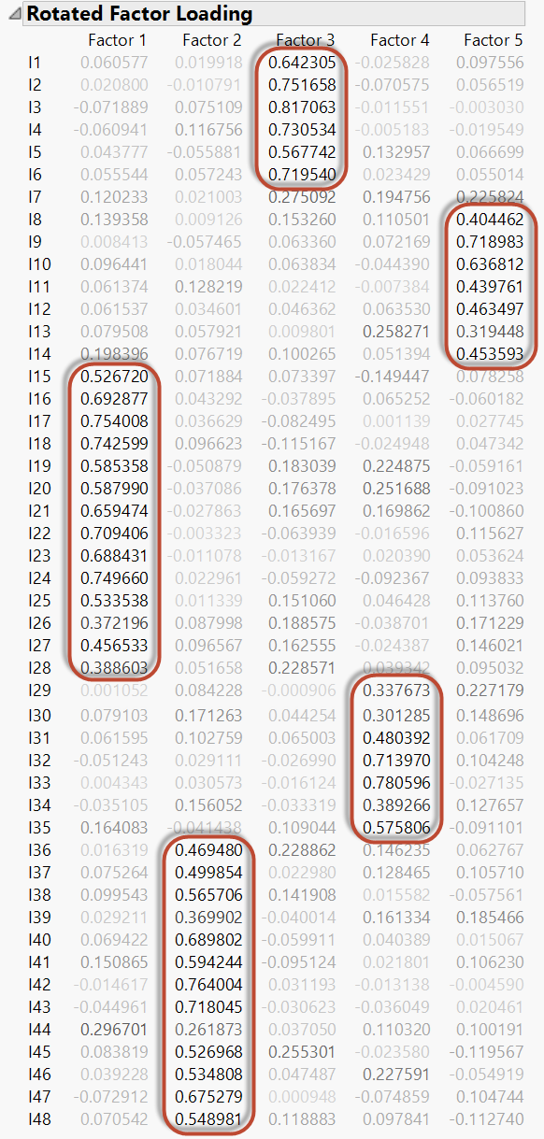
Table 5 – value interpretation of items of 5 Factors using Oblimin rotation

Result

- Identify the factor with the lowest reliability (i.e., lowest Cronbach’s alpha value). How many items would you need to add to this factor to ensure a Cronbach’s alpha value of at least 0.90?

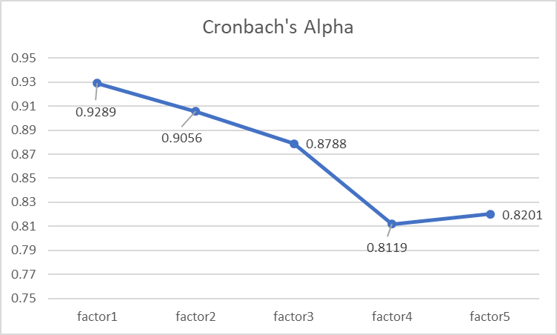
Figure 2 – cronbach’s entire set alpha of all 5 factors

For our lowest Cronbach alpha which is Factor 4 we ran a Spearman Brown Formula to discover the number of additional items required to have a Cronbach’s alpha of 0.90

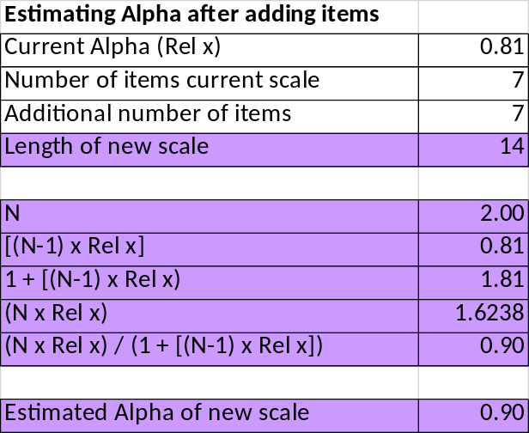
Table 6 – showing the results of the Spearman Brown Formula for factor 4 analysis

Discussion

From our analysis we found out that the optimum factor number was 5. Our analysis was based on two separate Rotation methods; Varimax and Oblimin. From both the results we chose Oblimin to conglomerate the items in their respective factor.
Based of this analysis we found that item7 was not loading high enough for any of the factors. We then removed it from the items list and ran Cronbach’s alpha per Factor.
The Cronbach’s alpha of all factors were higher than 0.80 with Factor 4 being the lowest. Factor’s 1 & 2 are both higher than 0.90.

Appendix A- Parallel Analysis in SPSS

Identify the number of factors
To identify the number of factors, Principal components analysis in JMP and Parallel Analysis in SPSS are conducted. According to the Eigenvalues results(see table1) and the Parallel analysis results(see table2) , it is suggested that there should be 5 factors. If the raw data eigenvalues are larger than the 95 percentile eigenvalues, the factor is recognized.

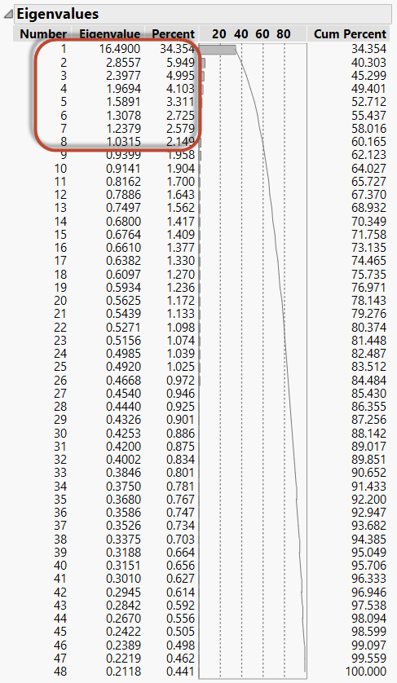
Table 7 - Eigenvalues with raw data

Run MATRIX procedure:

PARALLEL ANALYSIS:

Principal Components

Specifications for this Run:
Ncases 934
Nvars 48
Ndatsets 100
Percent 95

Random Data Eigenvalues
Root Means Prcntyle
1.000000 1.462254 1.497960
2.000000 1.416564 1.448817
3.000000 1.383477 1.414694
4.000000 1.355910 1.387278
5.000000 1.330296 1.357715
6.000000 1.305801 1.330358
7.000000 1.281137 1.306739
8.000000 1.258913 1.282410
9.000000 1.240272 1.262227
10.000000 1.220020 1.236605
11.000000 1.201950 1.217869
12.000000 1.183525 1.198948
13.000000 1.164767 1.179453
14.000000 1.148996 1.164258
15.000000 1.131566 1.144930
16.000000 1.115486 1.130191
17.000000 1.100057 1.113140
18.000000 1.083899 1.098910
19.000000 1.066628 1.076098
20.000000 1.051284 1.064658
21.000000 1.036756 1.050254
22.000000 1.020603 1.037029
23.000000 1.006328 1.021446
24.000000 .991731 1.008209
25.000000 .976258 .993488
26.000000 .962140 .977146
27.000000 .947332 .962792
28.000000 .932954 .947609
29.000000 .919057 .931606
30.000000 .905229 .920359
31.000000 .891125 .906824
32.000000 .877799 .889817
33.000000 .863637 .876258
34.000000 .849846 .863593
35.000000 .834785 .846761
36.000000 .820276 .831686
37.000000 .806046 .817613
38.000000 .793417 .806375
39.000000 .778526 .793830
40.000000 .763791 .778371
41.000000 .749405 .762973
42.000000 .733251 .745739
43.000000 .718282 .733435
44.000000 .701876 .718382
45.000000 .685556 .702394
46.000000 .666524 .685427
47.000000 .646999 .667145
48.000000 .617670 .639550

------ END MATRIX -----
Table 8 - Eigenvalues with Parallel Analysis

Factor Loading
According to table 3, There is no obvious cross loading and the sections in the original survey are well reflected. Thus, all 5 factors should be retained. and we can see that item 7 and 44 doesn’t load well in all 5 factors since the loading values are all less than 0.3. Below are the factors loading for each factor:

Factor 1: I15, I16, I17, I18, I19, I20, I21, I22, I23, I24, I25, I26, I27, I28
Factor 2: I36, I37, I38, I39, I40, I41, I42, I43, I45, I46, I47, I48
Factor 3: I1, I2, I3, I4, I5, I6
Factor 4: I29, I30, I31, I32, I33, I34, I35
Factor 5: I8, I9, I10, I11, I12, I13, I14

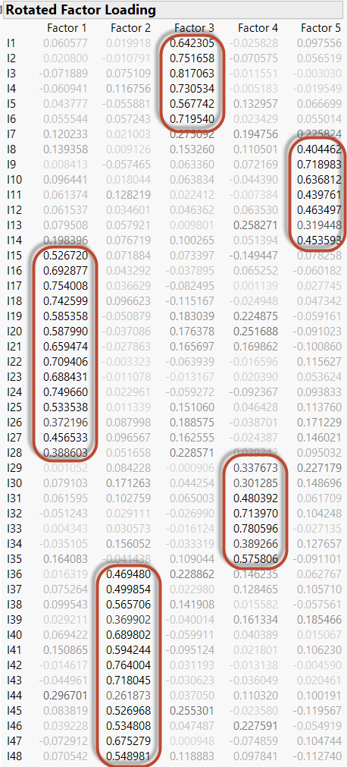
Table 9 – loading factors using SPSS
Item reliability Analysis
Through item reliability analysis, it is discovered that all the factors are reliable since their Cronbach’s alpha values are all higher than 0.81 while all the items have Cronbach’s alpha value lower than the factor Cronbach’s alpha. Below are the Cronbach’s Alpha values:

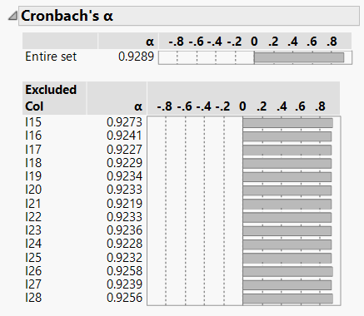
Figure 3 - Factor 1 -Cronbach’s Alpha using SPSS

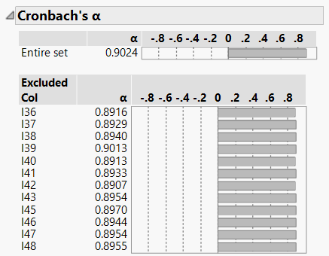
Figure 4 -Factor 2 -Cronbach’s Alpha using SPSS

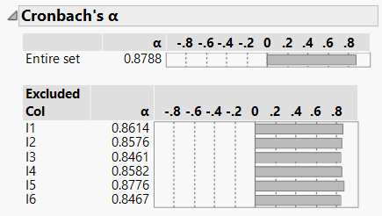
Figure 5 -Factor 3 -Cronbach’s Alpha using SPSS

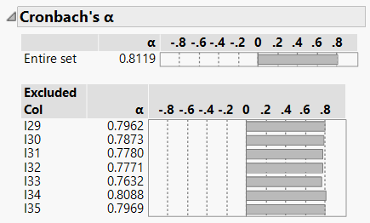
Figure 6 -Factor 4 -Cronbach’s Alpha using SPSS
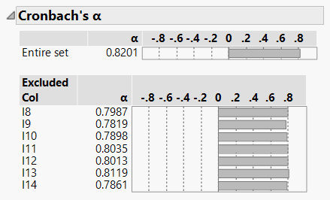
Figure 7 -Factor 5 -Cronbach’s Alpha using SPSS

Appendix B- Factor Analysis in Python
